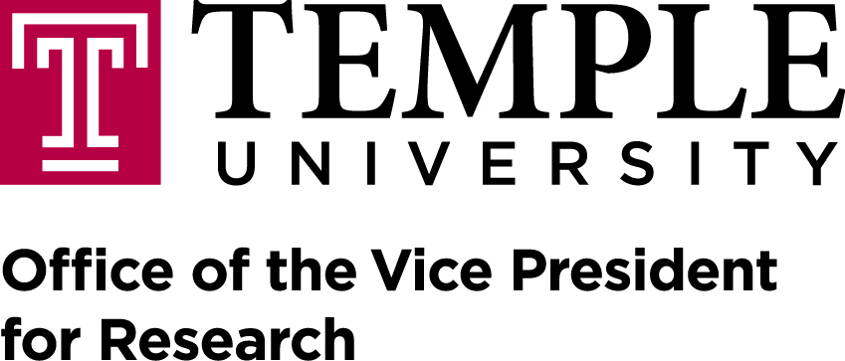
Technology Commercialization & Business Development
1801 North Broad Street
401 Conwell Hall
Philadelphia, PA 19122-6027
Phone: (215)204-6875 Fax: (215) 204-4609

MATERIAL TRANSFER AGREEMENT (MTA) INTAKE FORM

To be completed and submitted electronically to you contract specialist with any MTAs or other documents attached. For any questions, please contact the Office of the Vice Provost for Research at the contact information provided above.

Principal Investigator: Telephone Number: Date:

Provider: Institution/Company:
Providing Scientist: Email Address:
Administrative Contact Person:
Email Address: Telephone Number:

List the name of the institution/company that will provide the materials to be transferred if it is different from the Provider:

Material Recipient: Institution/Company:
Receiving Scientist: Email Address:
Administrative Contact Person:
Email Address: Telephone Number:

Description of Research Purpose:

Detailed description of material(s) being transferred (name, formula, strain/quantity/gender, etc.):
(If multiple items, please list materials requested)

Was material obtained under another MTA or was anything used to produce the material to be transferred obtained under another
MTA or other restriction(s)? (e.g. commitments to funding agencies, purchase agreements, etc.) NO YES
If YES, list provider(s), material(s), commitments, restrictions, and MTA number (if known):

For Incoming Material:
Is material available commercially? NO YES Do you anticipate any IP or Publications? NO YES
Are you purchasing material? NO YES
For Outgoing Material:

How did your lab originally obtain the material(s)? (RESPONSE REQUIRED)*
_______________________________________________________________________
Are you currently receiving royalties for the material or is the material currently licensed to a 3rd party? NO YES
Are you aware of any ongoing negotiations related to the material? NO YES
If created at TU, list TU account number and source(s) of funding that were used to produce material(s):

Will there be any charge for suppling the material? NO YES If yes, what amount should be listed in the MTA? $

Where should payments be sent? (address/contact/account)

Will Material be used for a Commercial Purpose? NO YES OTHER (PLEASE EXPLAIN) _____________

Should the Material be limited to non-commercial purposes? NO YES OTHER (PLEASE EXPLAIN)
___________

Are we limiting the amount of time the other party may keep possession of the material? NO YES

May the material or any resulting new material be shared with:
Other Universities Governmental organizations Commercial & industry partners
Non-profit organizations and foundations

Is the material to be transferred genetic material, biohazardous material, radioactive or a select agent/toxin? NO YES

If this involves human material, were they collected according to 45 CFR Part 46, “Protection of Human Subjects?” NO YES INCLUDE IRB# (pending/approved) N/A (Non-human)

If YES, does the human material include FETAL OR EMBRYONIC stem cells or material? NO YES

Are animals being transferred? NO YES If YES, provide IACUC#: (pending/approved)

Will the material involve an entity outside of the U.S.? NO YES If yes, will Temple share/receive material or data based on the research performed, please explain below?
*PLEASE NOTE: All requests for materials from foreign entities outside of the U.S. may need to be reviewed by University Counsel for Export Controls which may result in additional time to complete the process.
IMPORTANT: It is the responsibility of the P.I. to ensure that all regulatory approvals required for the receipt and use of this new Material be obtained PRIOR to its issue. This may require amending existing regulatory protocols or submission of new protocols to cover the use of this new Material. Also, please follow the University’s procedure for Receipt of Hazardous Materials.
* If the material came to Temple from an outside source, that transfer document must be checked for any restriction on sharing with another party. Often, when Temple receives material the related agreement may have certain provisions that restrict sharing or the need to flow-down terms to the proposed receiving party. Examples could include a restriction that does not permit sharing with certain 3rd parties (like for-profits), or requirement to obtain prior written consent from the original provider prior to sharing, or the original provider must be acknowledged in any publications resulting from the use of the material, etc.
Special Notes/Instructions:
(Example: Require Recipient to include Acknowledgement in their publications, etc?)

