TEMPLE UNIVERSITY - Research Administration

Institutional Biosafety Committee

STANDARD OPERATING PROCEDURE SOP# 1.0
BIOSAFETY LEVEL 1 (BSL1) PROCEDURES

BSL1 procedures: ______________________________________________________________________

- Purpose

This standard operating procedure (SOP) describes the safe BSL1 procedures.

- Approvals

All research using BSL1 procedures must have IBC and IACUC (if working with animals) approvals prior to initiation of any research work.

- Trainings

Principal Investigator is responsible to train all researchers, staff, and animal care providers on all aspects of this SOP.

- Security

- The laboratory supervisor must enforce the institutional policies that control access to the laboratory performing BSL1 procedures.

- Access to the animal room is limited. Only those persons required for program or support purposes are authorized to enter the BSL1 animal facility and the areas where infectious materials and/or animals are housed or manipulated.

- Escort the service workers (facilities engineer or BSC certifier), regulatory (OSHA, PaDEP, DOT, USDA, AAALAC), EHRS, IACUC inspectors at all times to the BSL1 room for services or inspection.

- Safety Equipment

- Biosafety Cabinet (BSC)

    - Certify the BSC annually by outside vendor to ensure continued, proper operation. Room(s): ________________________________________

    - Place two traps containing 10% bleach solution and a HEPA filter to protect the house vacuum line system from the backflow contamination of a BSL1 agent.

- Used sharps (needles, syringes, tips, pipettes, and any sharps objects) must be carefully placed in conveniently located puncture-resistant sharps containers. Do not recap needles!

- Emergency eyewash must be readily available.

- Check the eyewash station weekly. The facilities management check the eyewash station annually. Records of the weekly check must be readily available. Eyewash location: Room __________________________.

- Personal Protective Equipment (PPE)

- PPE

      - PPE for in vitro work in the laboratory are lab coat, goggle, and gloves for working with BSL1 procedures.

      - PPE for animal work are disposable gown, hair cover, mask, shoe covers, and gloves for animal work. PPE must be available for working with BSL1 animal procedures.

        - PPE donning procedure at the animal facility entrance

  - Don the disposable gown, hair cover, mask, shoe covers, and gloves before entering the BSL1 room.

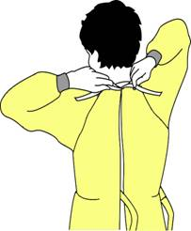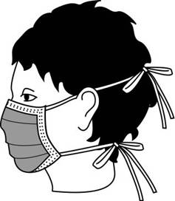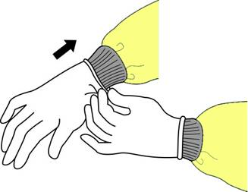

Gown ties in back Mask secures Gloves extend
on head over gown cuffs

  - Gloves should frequently be wetted with disinfectant and should be changed when contaminated or torn.

        - PPE doffing procedure at the animal facility exit area.

- Doff the hair cover, mask, shoe covers.

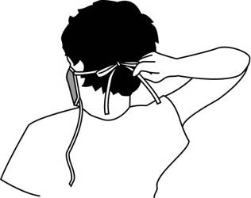 Untie the bottom, then top
Remove from face and discard

- Doff the disposable gown

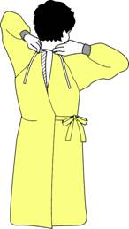
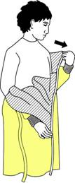
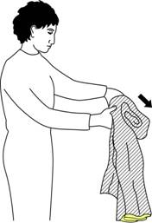
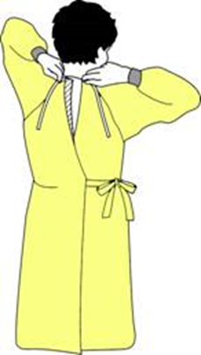

Unfasten ties Peel gown away from Turn contaminated outside
neck and shoulder toward the inside and roll into a bundle

- Doff the gloves

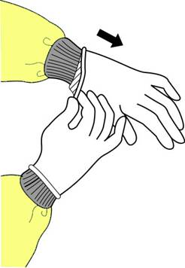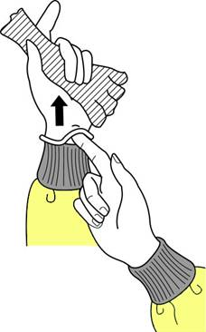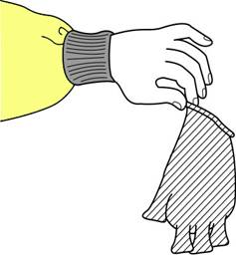

Peel away from hand Slide ungloved finger Create a bag from both gloves
Turing gloves inside-out Peel off from insdie Discard in a red bag

- Dispose All the PPE in a red bag.

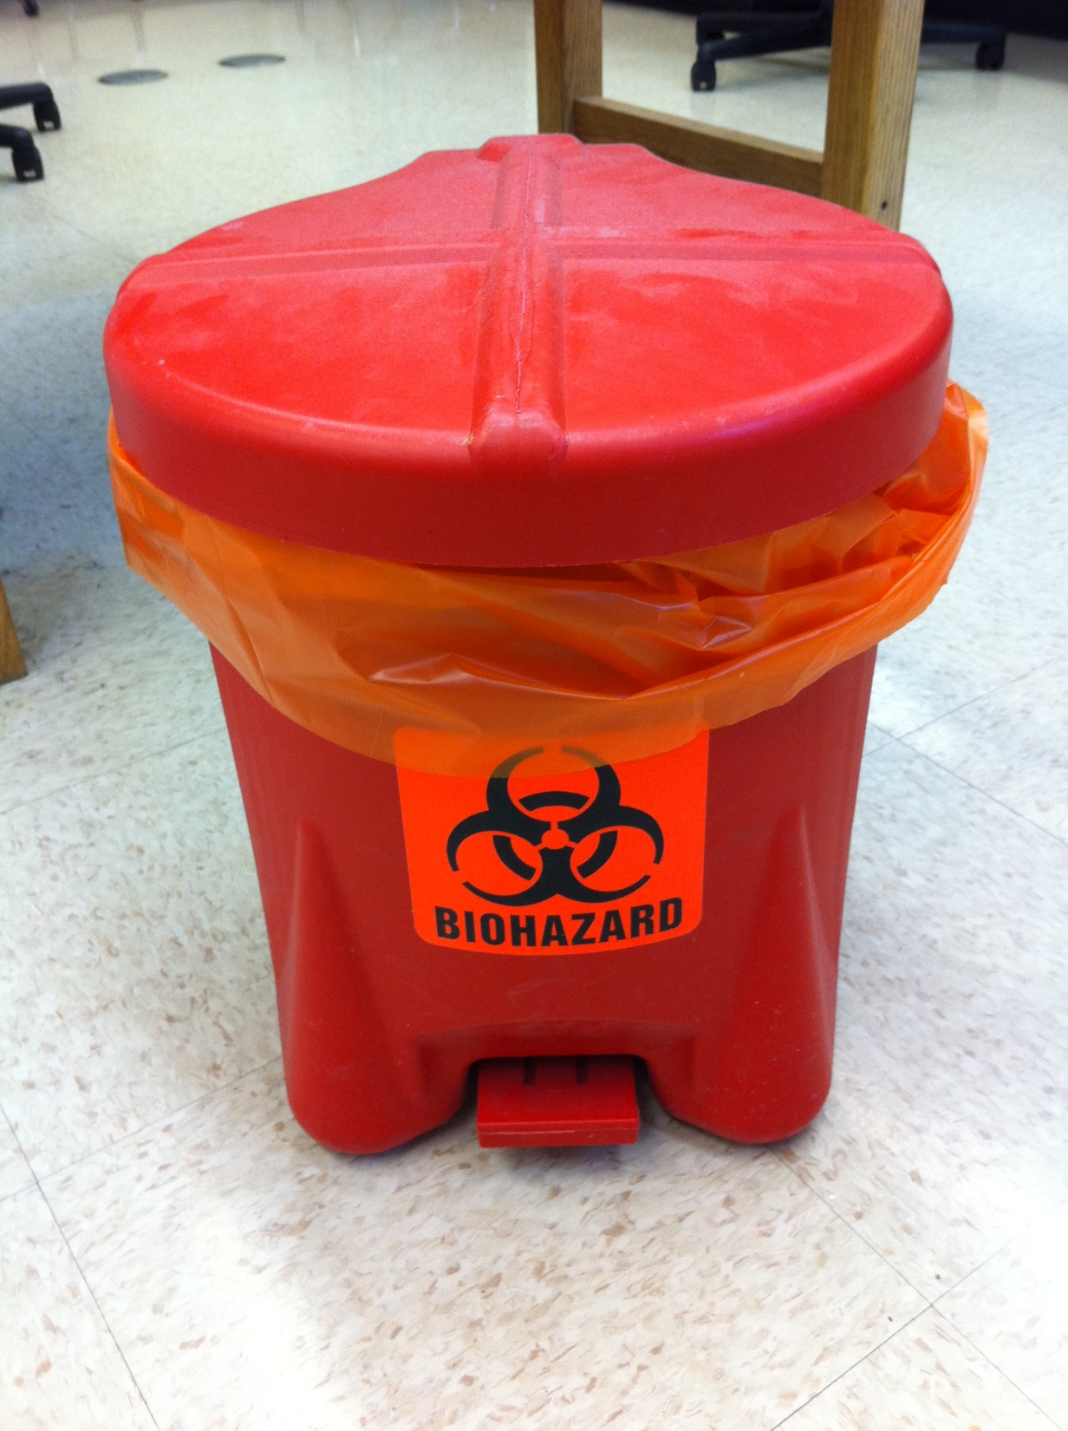 Solid container required to have a lined red bag, a lid, and a biohazard symbol.

- Persons must wash their hands after working with BSL1 materials and before leaving the laboratory.

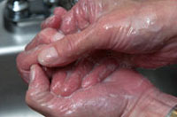

- Decontamination

Use 10% bleach or Quatricide®PV-15 solution to wipe down equipment and work surfaces for decontamination before and after performing BSL1 procedures.

- Soiled Animal Cage Changing, Decontamination and Equipment Removal (This section only applies for performing BSL1 procedures in animal studies)

- Spray BSC work surface with approved disinfectant (e.g. Quatricide PV-15) and wipe down.

- Place the soiled microisolator cage in a BSC and change animals into a clean cage. Room(s): _________________________________

- Soiled caging material and Hydropac™ water pouches

  - In the animal room, after moving animals to a clean cage, combine empty soiled caging materials (cages, diet trays, Lifespan™ platforms, filter tops, Hydropac™ water pouches and lixit valves) and place either on a cart or hand carry (if a small amount of materials) to destination below.

    - In the MERB facility - remove materials from the animal room and place on a dedicated soiled material racks located in the corridor outside soiled side cage wash.

    - In the MOB, MRB and Pharmacy buildings - remove materials from the animal room and place directly on a dedicated rack inside soiled side cage wash.

- Spray BSC work surface with approved disinfectant (e.g. Quatricide PV-15) and wipe down.

ULAR will change all caging: yes ___ no ___
Laboratory staff will change all, or some, caging: yes___ no ___

- Biological Waste Management

- For laboratory in vitro work, place all solid waste in a red bag to be picked up by a certified vendor. Place all sharps items in a sharps container to be picked up by certified vendor. Chemically disinfect (10% bleach, 10 minutes contact time) all infectious liquid waste before release to sanitary sewer.

- Place animal carcasses in a red biohazard bag in a BSC. Securely seal the bag and spray Quatricide®PV-15 solution to exterior of the bag before removal from BSC. Place the carcasses in the ULAR carcass freezer (Room: __________________________).

- Spill Management

    - Don the lab coat, goggles, and gloves in the laboratory or follow the PPE donning procedure in Section G, when cleaning a spill in the lab area or animal facilities.

    - Contain the spill by covering with absorbent pads or paper towel.

    - Disinfect the spill by adding 10% bleach and 10 minutes contact time.

    - Carefully remove potentially contaminated protective clothing as mentioned in the section of PPE doffing procedure if there is a splash in the protective equipment.

    - Dispose all solid wastes generated from spill in a red bag. Place all sharps items in a sharp container.

- Emergency Response

- Wash the affected areas with copious amounts of lukewarm water in the event of personnel exposure such as eye, skin, mucous membranes or body fluids contact when performing a BSL1 procedure.

- Report to PI and seek immediate medical evaluation if there is personnel exposure

    - During office hour
    - Health Science Center: Go to the Occupational Health Department, M-F, 8:00 AM to 5:00 PM.
    - Main Campus: Go to Employee Health Services, M-F, 8:30 am - noon; 1 pm - 4:40 pm.

    - After office hour
  - After 5 PM, go to Temple University Hospital Emergency Department.

- Principal Investigator must immediately report the incident to the EHRS.

- Date of the SOP#1.0 traoning for lab workers and animal care providers: _______________________

Name (please print) | Signature | TuID Number | Department | Position / Title

