How to create a CITI account and start mandatory courses

Table of Contents
CITI Overview: 2
To gain access to the CITI program: 3
To gain access to the CITI program for the first time at Temple: 3
To add courses to your Curriculum: 8
To update your Temple University CITI profile: 13

Temple University Human Research Protections Program (HRPP)
Temple University Office for Human Subject Protections (OHSP)
Temple University Institutional Review Board (IRB)

CITI Overview:
CITI – Collaborative Institutional Training Initiative is the premiere online human subjects education program. It is currently used by more than 700 institutions and growing. It was created, developed, and is maintained by experts from the human subjects research community.

Mandatory CITI education fulfills Temple University commitment to promote ethical conduct towards Human Subjects in all research projects, funded or unfunded. Temple University maintains an Assurance from the Office for Human Subject Protections identified as FederalWide Assurance 00004964. As part of the Assurance, Temple University is committed to following the ethical principles found in the Belmont Report and assures that all Faculty, Staff, and Students involved in human subject research projects receive IRB education in Human Subject Protections.

An IRB application, with personnel listed who do not have valid proof of current CITI education for all members of the study team WILL NOT BE APPROVED by the IRB and will be returned to the PI. The required CITI courses are:
- Social & Behavioral Research Investigators OR Biomedical Research Investigators (depending on the type of research being done): required within the past two years
- Practice Runs Training: required within the past one year
- Good Clinical Practice: required if the study is a Clinical Trial as defined by the NIH or FDA.
- Responsible Conduct of Research (RCR): required if the study is being funded by the National Science Foundation (NSF)

NOTE: The training entitled Students conducting no more than minimal risk research is only applicable for Classroom Projects as defined in the Application for Human Research.

The CITI program offers:
- Dynamic organization committed to providing quality instructional resources to the research community.
- Comprehensive content.
- Institutionally driven course content.
- Economy of time for the user.
- Content for the Biomedical Research Community and for the Social/Behavioral Research Community.
- The course is available 24/7/365 from nearly anywhere.
- A “user friendly” presentation and assessment tools.
- Help Desks for users and administrators.

Each CITI module has text to read and a quiz to complete. The average learner spends approximately 4.5 hours in the Basic Course site and uses approximately 5 logins to complete the course

To Gain Acess to the CITI program:

- Go to the CITI website (citiprogram.org) and click Log In in the upper right corner.
- Select “Log In Through My Organization” and locate Temple University. It is imperative that you do not log in to an existing account from a previous institution. Temple can not be added via “Add Affiliation.” You may need to use “Private Browsing Mode” or “Incognito Mode” (depending on your browser) to prevent automatically loggging into CITI via your previous institution.

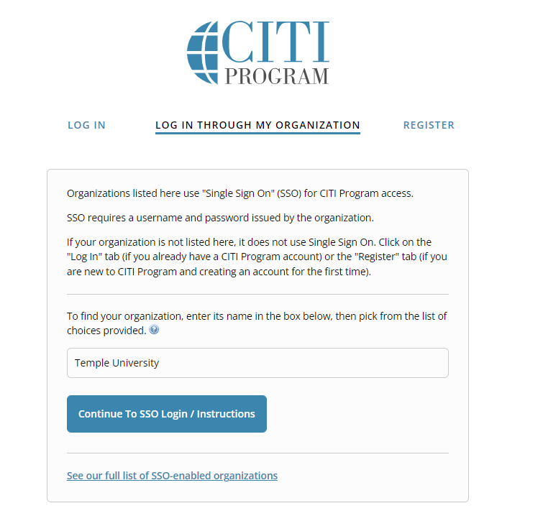
- Select “Continue to SSO Login.” Enter your Temple University AcessNet login and password (Note: Do NOT use TUHS login)

To Gain Acess to CITI program for the first time at Temple:

- Follow the steps under To gain access to the CITI program:
  - If you have an existing CITI profile, your account set-up is complete. The steps above will automatically update your name, affiliation to Temple, email address, and employee number. Skip to “To add Courses to your Cirriculum” below.

- Select “ I do not have a CITI Program account and I need to create one.” You will then follow the steps to create a new account.

- If this is your first time creating a profile, a “Temple University Profile” will be created automatically on the CITI site from the login information. Your Temple affiliation, name, University email address and employee number will be automatically populated. The remaining information can be completed manually.
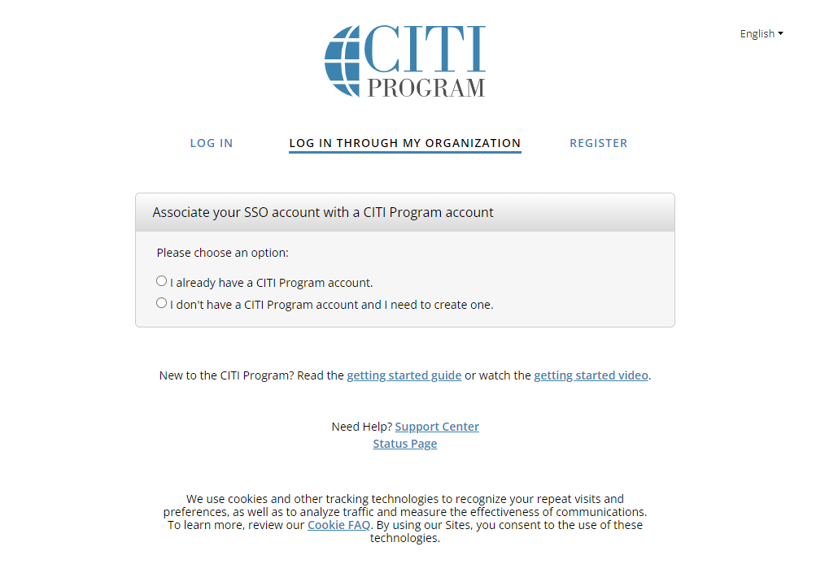
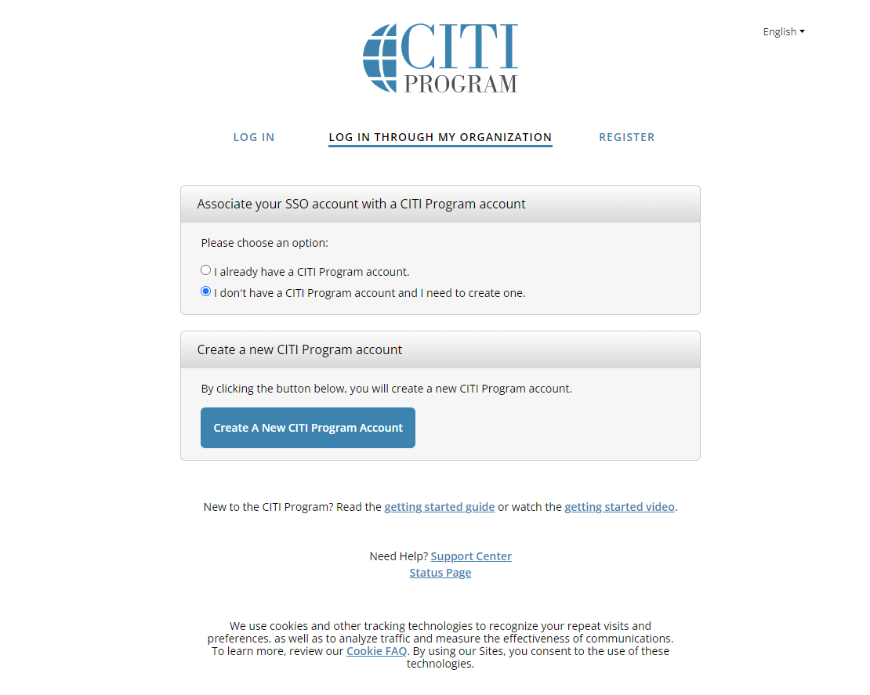

- Complete the required information then continue to Step 3
  - Note: Please use your @temple.edu email address, if you have an @tuhs.temple.edu email address, use that as a second email.
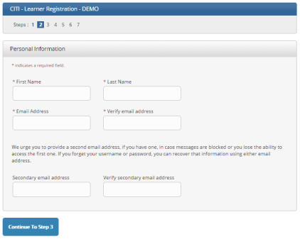

- Fill in the required fields – Username, Password, Secruity Questions, and Answer then continue to Step 4.
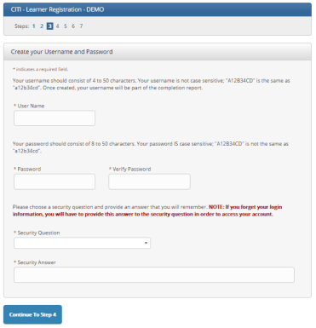

- Complete the Country of Residence section then continue to Step 5
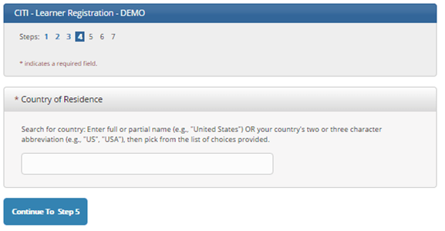
- If you are seeking credit for CITI Program courses, you can make your selection for Continuing Education credits during Step 5. This voluntary and the CE credits will be available for you to purchase after the course is completed. This step is also where you would indicate your interest in participating in research surveys at a later date. Then continue to Step 6.
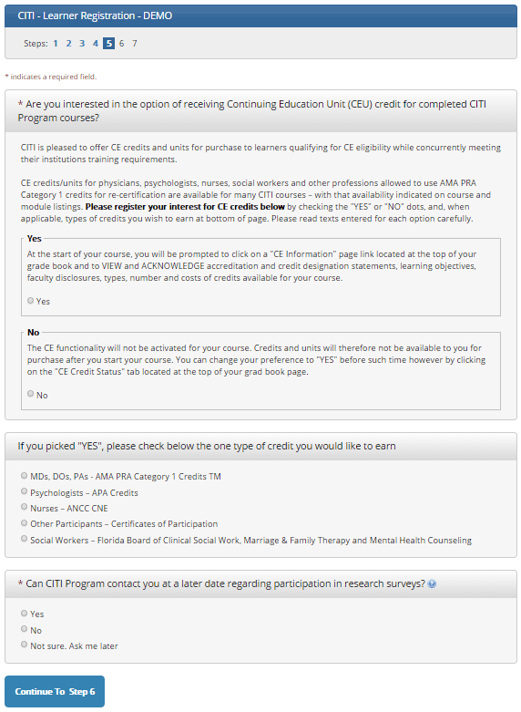

- Fill in the required fields: your institutional email address, gender, highest degree, your role in human subjects research, office phone, and your Temple University 9 digit ID number. Some of this information will be automatically populated
    - Important: The “TU ID” is the University TU ID and not the TUHS ID.
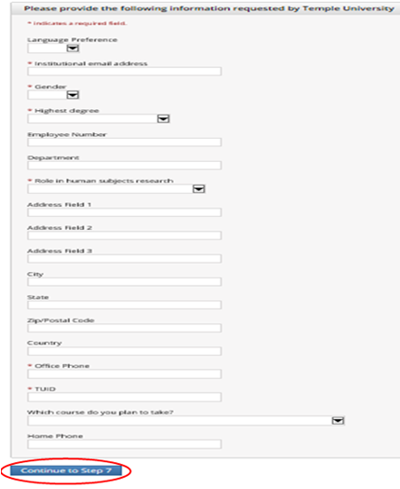

To add Courses to your Cirriculum:

- Select “My Courses” and scroll to the bottom of the page and select “Add a Course.”

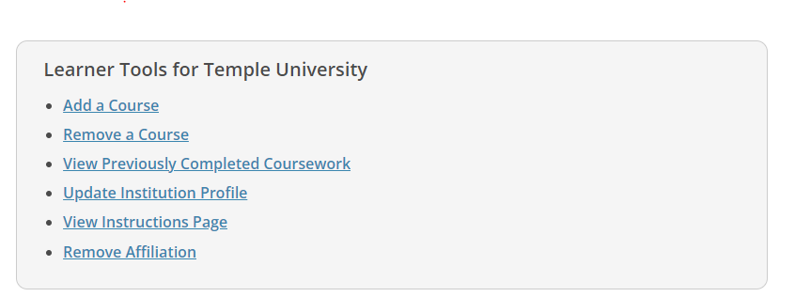

- Answer questions 2-4.
Question 2
- If you are a member of the Biomedical Research Community (Medical Research) you will pick the Biomedical Module

- If you are a member of the Social and Behavioral Research Community you will pick the Social & Behavioral Module

- If you are a member of the IRB you will pick the IRB Member Modules

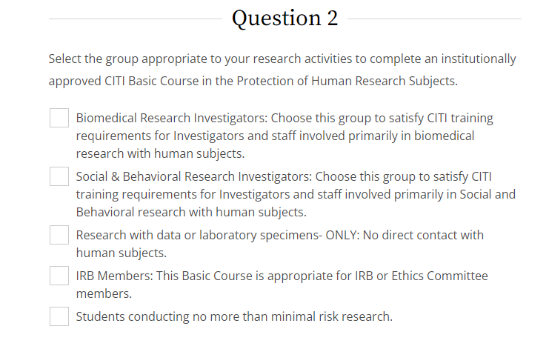

Question 3

- If your study is a Clinical Trial (as defined by the NIH or FDA) you will pick Good Clinical Practice and ICH.

- If your study is funded by the National Science Foundation (NSF) you will pick Responsible Conduct of Research (RCR).

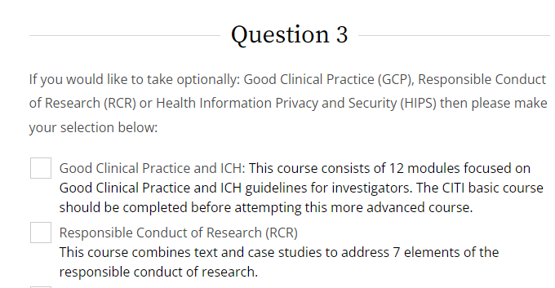

Question 4

- This course must be completed in order to be in compliance with Temple University IRB Requirements.

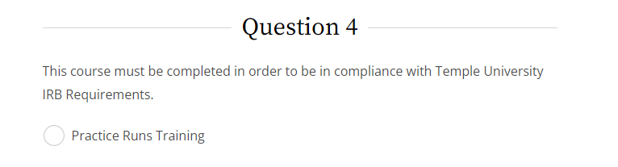

To Add Another Institution:

- Go to the CITI website (citiprogram.org). (If already logged in, skip to Step 4 below)
- Select “Log In Through My Organization” and locate Temple University.

- Select “Continue to SSO Login.” Enter your Temple University AcessNet login and password (Note: Do NOT use TUHS login)
- Select “My Courses” and then “Add Affiliation.”
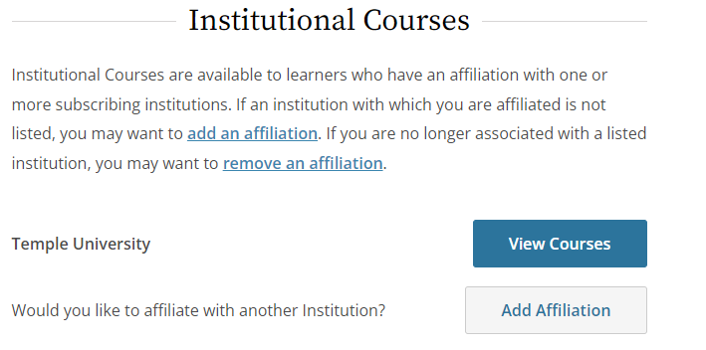

- When you are affiliated with both institutions, enroll in the courses that need to be transferred You will need to enroll in the same stage of the course (Basic / Refresher) for a transfer to occur.
- Once the other institution is added, your previously completed modules will transfer over.
  - Please note: only currently active certifcations will transfer and the modules needs to be in a course Temple University already offers.
  - All courses a comprised by a variety of modules. Different institutions may have the same Course title, but have different module requirements within that course.
  - Modules that TU does not offer will not transfer. So, even if you had completed Biomedical Research Course at your previous institution, you may still need to complete additional modules to complete the Biomedical Research Course here at Temple.

To update your Temple University CITI Profile:

- On the main page, select the drop down arrow next the magnifer glass. Then choose “Profiles”:

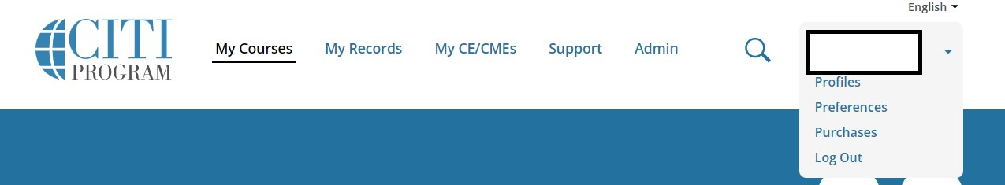

- On the “Profiles” page select scroll down to “Institutional Proflies” and select “Edit Profile” next to Temple University:
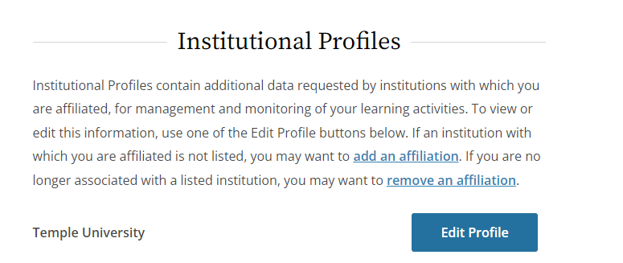
- On the Temple University Profile page, complete all required fields (indicated with a red asterisk). You must include your @temple.edu email address and your 9-digit TUID in order for your CITI training profile to be accessible by the TUIRB. Click Update Profile when complete:

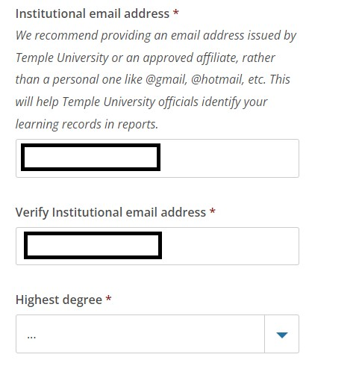
    - Note: - A temple.edu email address is required

- Click “Update ” when complete:

